
Lab Continuous Assessment Task -II – Mini Project
“Identifying and Analyzing Traffic Congestion Patterns in Urban Environments”

by
16010123012 Aaryan Sharma
16010123080 Aryan Raut
16010123135 Tanmay Chinchore

For the subject

Machine Learning

Honours in Data Science
And Analytics Year 2025-26

Identifying and Analyzing Traffic Congestion Patterns in Urban Environments
This report details the development of a machine learning framework designed to identify and predict traffic congestion patterns in urban environments. By integrating Random Forest classifiers for state identification and Long Short-Term Memory (LSTM) networks for spatio-temporal forecasting, the project provides a data-driven alternative to traditional, static traffic management systems.
Introduction
As the global population undergoes a historic transition toward urban living with projections suggesting that nearly 68% of humanity will reside in cities by 2050. The strain on existing infrastructure has reached a critical threshold. Within this context, traffic congestion has ceased to be a localized inconvenience; it has evolved into a systemic failure that imposes staggering costs on productivity, environmental health, and the psychological resilience of urban dwellers.
The escalation of traffic congestion is rooted in the mismatch between travel demand and static road infrastructure. Since 2008, more than half the world's population has been concentrated in cities. The economic implications are profound, with data indicating that traffic congestion can strip cities of up to 3% of their annual Gross Domestic Product (GDP) due to lost work hours and disrupted supply chains. In the United States alone, the economic burden of wasted fuel and time is projected to exceed $100 billion by 2030.
Problem Statement
Traditional urban traffic control often relies on fixed-time signal cycles that cannot adapt to real-time fluctuations in vehicle density. These systems suffer from:
- Reactive Management: Delays propagate through the network before adjustments are made.
- Data Fragmentation: A lack of integrated processing for GPS, IoT, and weather data .
- Non-linear Complexity: Small disruptions cause network-wide "butterfly effects".
This project addresses these challenges by implementing a computational framework that classifies congestion in real-time and provides predictive insights using temporal sequence analysis.
Methodology
The methodology follows a structured pipeline: Data Acquisition, Pre-processing, Feature Engineering, Model Training, and Evaluation. This project utilizes Python libraries such as Pandas for data manipulation, Scikit-learn for the Random Forest model, and TensorFlow/Keras for the LSTM architecture.

Tech Stack and Model Selection
- Python: The primary programming language for data orchestration.
- Pandas & NumPy: Utilized for high-performance data manipulation and cleaning.
- Scikit-learn: Employed for implementing the Random Forest classifier and evaluation metrics.
- TensorFlow/Keras: Used for the architecture and training of the Long Short-Term Memory (LSTM) networks.

System Architecture
The following diagram illustrates the data flow and system architecture:
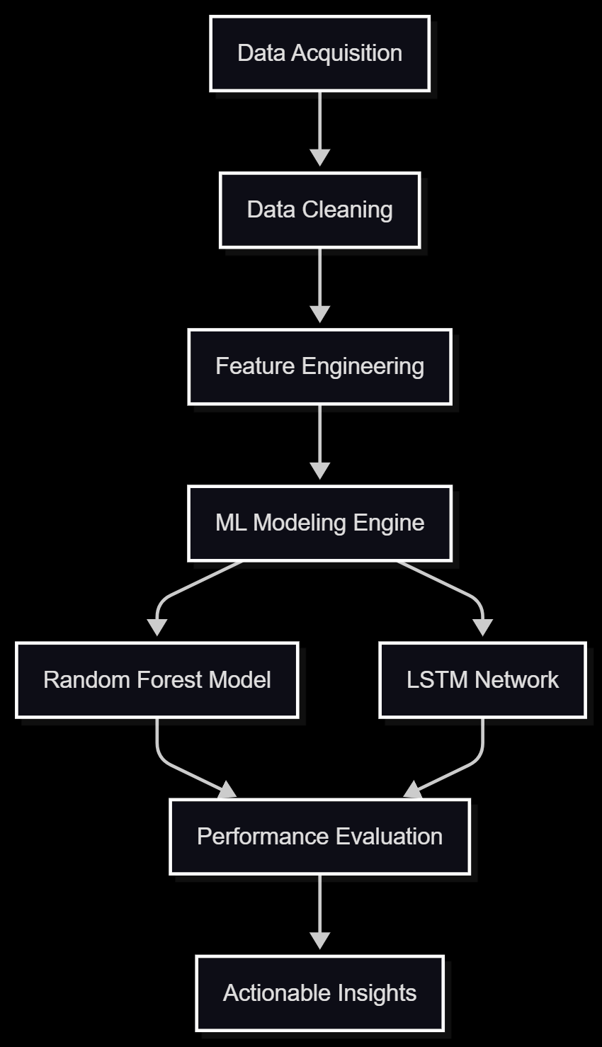
Feature Engineering and Data Normalization
Raw traffic data is often plagued by inconsistencies due to sensor failure.¹⁴ To mitigate this, pre-processing includes:
- Min-Max Scaling: Essential for bringing varying features (like temperature and vehicle count) into a common range of 0 to 1.
- Sliding Window Approach: For LSTM, data must be formatted as sequences. If we predict traffic for the next 15 minutes, we might use the previous 60 minutes of data as the input vector.
- Cyclic Features: Time of day is transformed using sine and cosine functions to ensure the model understands that 23:59 and 00:01 are close in temporal space.
Pseudo code, flow chart
The operational logic follows a sequence designed to transform raw input into predictive intelligence.
Algorithmic Flow Chart
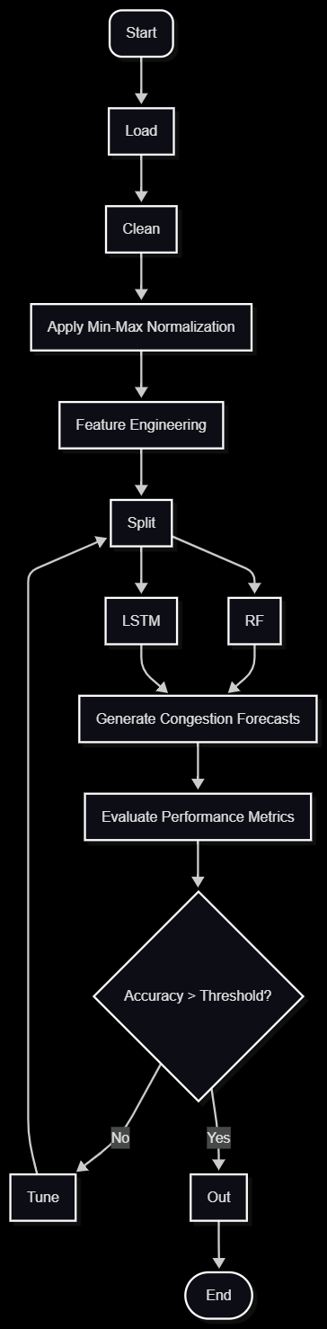
Pseudo Code
- Initialize data pipeline and load CSV/API traffic datasets.
- Pre-process by handling missing values and removing sensor noise.
- Normalize features using X_{scaled} formula to ensure uniform variance.
- Transform time-stamps into (sin, cos) pairs to capture daily cycles.
- Segment data using a sliding window of size N = 12 (for 60-min history).
- Train Random Forest Regressor to identify feature importance.
- Execute LSTM network training with Adam optimizer and Dropout layers.
- Evaluate results using RMSE and R² scores.
Results and analysis
Evaluation of the models reveals that combining Random Forest and LSTM provides a comprehensive view of congestion dynamics. While LSTM captures long-term trends, Random Forest excels at managing discrete "events" like sudden rainfall.
Performance Evaluation Metrics
Models are evaluated using three primary metrics:
- Mean Absolute Error (MAE): The average difference between predicted and actual traffic volume.
- Root Mean Squared Error (RMSE): Penalizes larger errors, which is critical for identifying rare "extreme" congestion events.
- Accuracy/R-squared: Measures the variance captured by the model. Random Forest often achieves an R² value of 0.95 for travel time regression, while LSTM accuracy for short-term prediction ranges between 88% and 99%.
Comparative Results
Algorithm | Tasks | Strengths | Reported Accuracy
Random Forest | Level Classification | Interpretable, handles non-linear factors | 92.0% - 96.8% ¹⁷
LSTM | Flow/Speed Forecast | Captures temporal dependencies | 90.0% - 99.0% ⁸
XGBoost | Regression | Highly efficient for large datasets | Comparable to RF ¹⁷
ARIMA | Forecasting | Good for simple, stationary series | Lowest performance in urban chaos ⁸
Future Directions: Towards Intelligent Cities
The results suggest several avenues for future urban traffic management :
- Multi-Agent Reinforcement Learning (MARL): Moving toward decentralized control where intersections act as "agents" to self-organize signal timings based on real-time neighbor data.²
- Proactive Route Guidance and MaaS: Integrating predictions into Mobility-as-a-Service (MaaS) platforms to redistribute traffic 20 minutes before a forecasted bottleneck forms.¹⁴
- Policy Integration: Using real-time models to manage Low-Emission Zones (LEZ), restricting vehicle types during periods of high predicted congestion to protect air quality.¹⁴

Conclusion
This project has demonstrated that urban traffic congestion is not merely a failure of road space, but a failure of management efficiency. By applying Random Forest for classification and LSTM for temporal prediction, this framework transforms raw data into actionable intelligence. With model accuracies reaching up to 99%, the transition from static to adaptive, data-driven systems offers a viable path toward reducing the carbon footprint of transportation and improving the quality of life for urban residents.

References
- Urban traffic congestion: Its economic and social causes and consequences - ResearchGate, accessed on April 20, 2026, https://www.researchgate.net/publication/331236844_Urban_traffic_congestion_Its_economic_and_social_causes_and_consequences
- Addressing the urban congestion challenge based on traffic ..., accessed on April 20, 2026, https://royalsocietypublishing.org/rsta/article/382/2285/20240095/108325/Addressing-the-urban-congestion-challenge-based-on
- Revolutionizing Smart Cities: The Future of Traffic Management - Bitsensing, accessed on April 20, 2026, https://www.bitsensing.com/blog/revolutionizing-smart-cities-the-future-of-traffic-management
- Evaluation of the public health impacts of traffic congestion: a health risk assessment - PMC, accessed on April 20, 2026, https://pmc.ncbi.nlm.nih.gov/articles/PMC2987789/
- Traffic Congestion Prediction Using Machine Learning Techniques - arXiv, accessed on April 20, 2026, https://arxiv.org/html/2206.10983v4
- Traffic Congestion Prediction Using Machine Learning Algorithm - Cureus Journals, accessed on April 20, 2026, https://www.cureusjournals.com/articles/1981-traffic-congestion-prediction-using-machine-learning-algorithm
- Traffic Flow Prediction via a Hybrid CPO-CNN-LSTM-Attention Architecture - MDPI, accessed on April 20, 2026, https://www.mdpi.com/2624-6511/8/5/148
- A CNN-LSTM-GRU Hybrid Model for Spatiotemporal Highway Traffic Flow Prediction - MDPI, accessed on April 20, 2026, https://www.mdpi.com/2079-8954/13/9/765
- Implementing Real-Time Traffic Flow Prediction Using LSTM Networks for Urban Mobility Optimization - ResearchGate, accessed on April 20, 2026, https://www.researchgate.net/publication/384415702_Implementing_Real-Time_Traffic_Flow_Prediction_Using_LSTM_Networks_for_Urban_Mobility_Optimization
- Ensemble Machine Learning Approach for Traffic Congestion and Travel Time Prediction in Urban Bus Rapid Transit Systems: A Case Study of Trans Metro Bandung - MDPI, accessed on April 20, 2026, https://www.mdpi.com/2624-831X/7/1/22
- Big Data in Urban Traffic Management: Current Applications, Challenges, and Future Directions, accessed on April 20, 2026, https://drpress.org/ojs/index.php/ajst/article/download/32557/31863
- Traffic Prediction Using LSTM, RF and XGBoost - SciTePress, accessed on April 20, 2026, https://www.scitepress.org/Papers/2024/135156/135156.pdf
- Traffic congestion prediction based on Estimated Time of Arrival - PMC - NIH, accessed on April 20, 2026, https://pmc.ncbi.nlm.nih.gov/articles/PMC7743965/
- The major challenges of traffic management up to 2030 - Openvia, accessed on April 20, 2026, https://www.openvia.io/the-major-challenges-of-traffic-management-up-to-2030/
- ML LAB CA2 Report.docx
- The Traffic Congestion Prediction Using Machine Learning - IRJIET, accessed on April 20, 2026, https://irjiet.com/common_src/article_file/1714638783_863e045d79_8_irjiet.pdf
- Short-Term Traffic Forecasting: An LSTM Network for Spatial-Temporal Speed Prediction, accessed on April 20, 2026, https://www.mdpi.com/2673-7590/1/1/3

